**INTERNSHIP AT 1RIVET INDIA**

# AN INDUSTRY INTERNSHIP REPORT

***Submitted By***

# PATEL JAITRY JAYANTIBHAI

190180107040

***In partial fulfillment for the award of the degree of***

# BACHELOR OF ENGINEERING

***in***

**[Computer Engineering]**

# GOVERNMENT ENGINEERING COLLEGE, DAHOD



**Gujrat Technological University , Ahmedabad**

**May , 2023**

 

**Government Engineering College, Dahod**  **Jhalod Road, Dahod, Gujarat 389151**

# CERTIFICATE

This is to certify that the project report submitted along with the project entitled **Internship** has been carried out by **Patel Jaitry Jayantibhai** Under my guidance in partial fulfillment for the degree of Bachelor of Engineering in computer Engineering, 8th Semester of Gujarat Technological University , Ahmedabad during the academic year 2022-2023

Prof. Dipen Contractor Prof. Viren J Patel

Internal Guide Head of the Department

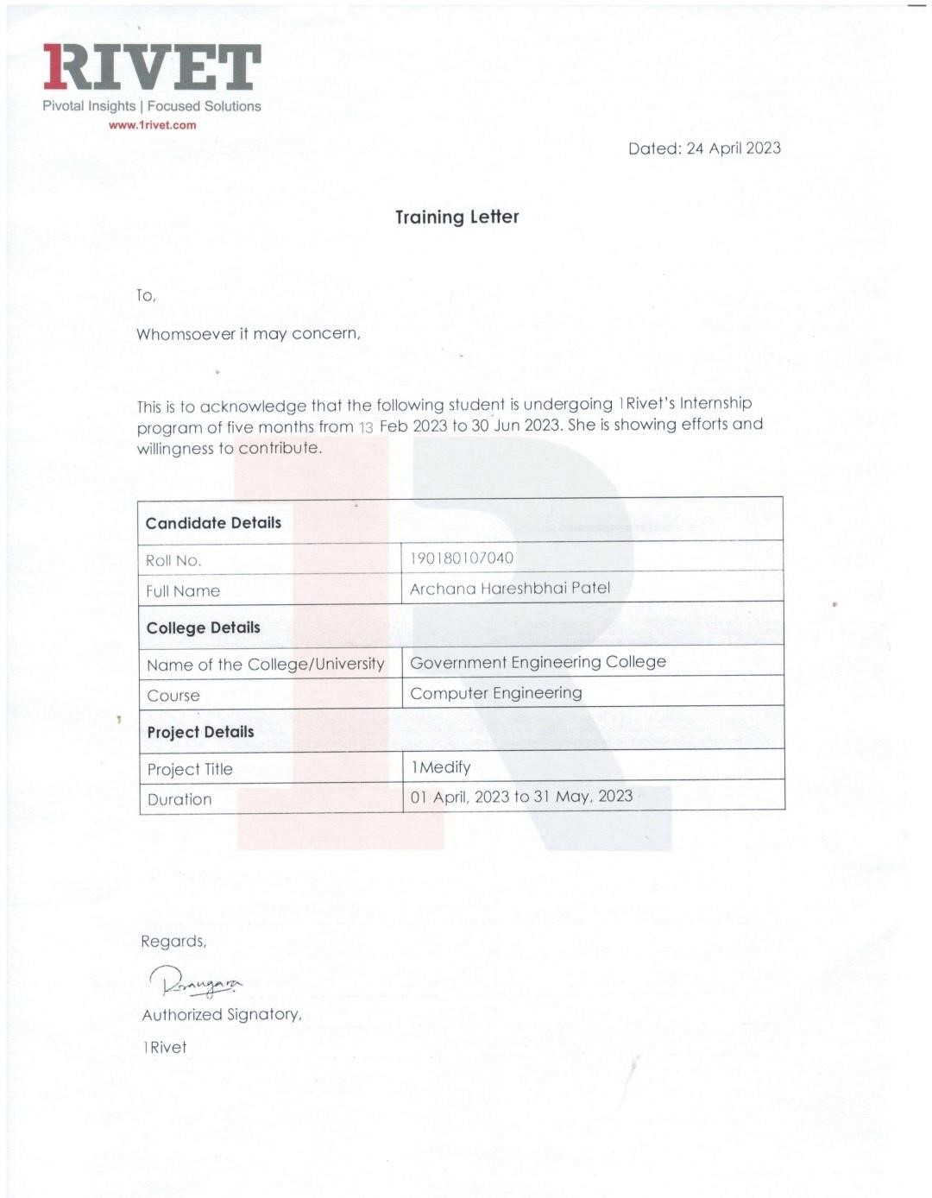

 

**Government Engineering College, Dahod**

**Jhalod Road, Dahod, Gujarat 389151**

# DECLARATION

We hereby declare that the Internship report submitted along with the Internship entitled **Internship At 1Rivet India** submitted in partial fulfillment for the degree of Bachelor of Engineering in Computer Engineering to Gujrat Technological University , Ahmedabad, is a Bonafede record of original project work carried out by me at 1Rivet India ,under the supervision of Revant Patel and that no part of this report has been directly copied from any students’ report or taken from any other source, without providing the references.

Patel Jaitry Jayantibhai 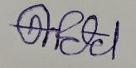

Name of the Student Sign of Student

## ACKNOWLEDGEMENT

The internship opportunity I had with **1Rivet India**  was a great chance for learning and professional development. Therefore, I consider myself as a very lucky individual as I was provided with an opportunity to be a part of it. I am also grateful for having a chance to meet so many wonderful people an professionals who led me though this internship period.

I express my deepest thanks to **Mr. Revant Patel,** Senior developer of the company for taking part in useful decision & giving necessary advice an guidance an arranging all facilities to make life easier. I choose this moment to acknowledge his/her contribution gratefully.

I would like to **thank Mr. Dipen Contractor, Computer Department internship mentor** at Government Engineering College, Dahod for their support and advices to get and complete an internship in the above-said organization.

We are thankful to Gujarat Technological University to giving the opportunity for assigning this **Industry Internship** work.

Thank You

Patel Jaitry Jayantibhai

## ABSTRACT

*Internship is a comprehensive learning platform for students where they can enhance their employability skills and become job-ready along with real corporate exposure.*

*It enhances student’s knowledge of one particular technology and to increase the self-confidence of students and help in finding their own proficiency.*

*It cultivates student leadership ability and responsibility to perform or execute the given task.*

*Also, it provide learner hands-on practice within a real job situation.*

## LIST OF FIGURES

Figure 1.5 Our Approach ................................................................................. 2

Figure 2.3 Stage of Production ........................................................................ 4

Figure 3.7.2.1 Create dashboard .................................................................... 12

Figure 3.7.2.2 Create from & Table............................................................... 12

Figure 3.7.2.3 Create Table ........................................................................... 13

Figure 5.1.1 Use Case Diagram For Doctor Module ..................................... 20

Figure5.1.2 Use Case Diagram For Patient Module ...................................... 21

Figure5.1.3 Use Case Diagram For Pharmacy Module ................................. 22

Figure 5.2.1 Registration Activity Diagram .................................................. 23

Figure 5.2.2 Doctor’s Activity Diagram .......................................................... 24

Figure 5.2.3 Pharmacy’s Activity Diagram ................................................... 25

Figure 5.2.4 Patient’s Activity Diagram ........................................................ 26

Figure 5.3 Class Diagram ............................................................................... 27

Figure 5.4.1 Conceptual Data Model ............................................................. 28

Figure5.4.2 Logical Data Model .................................................................... 29

Figure5.4.3 Physical Data Model .................................................................. 30

Figure 6.1 Home Page ................................................................................... 37

Figure 6.2 Doctor’s Registration Page .......................................................... 37

Figure 6.3 Patient’s Registration Page ........................................................... 38

Figure 6.4 Pharmacy’s Registration Page ...................................................... 38

Figure 6.5 OTP Verification .......................................................................... 39 Figure 6.6 Sign In .......................................................................................... 39

Figure 6.7 Forget Password ........................................................................... 40

Figure 6.8 Reset Password ............................................................................. 40

Figure 6.9 Doctor’s Home Page .................................................................... 41

Figure 6.10 Doctor’s My Patient Page .......................................................... 41

Figure 6.11 Doctor’s View Prescription of Pharmacy Page .......................... 42

Figure 6.12 Doctor’s View Prescription of Patient Page .............................. 42

Figure 6.13 Doctor’s Approved Prescription................................................ 43

Figure 6.14 Doctor’s Pharmacies Page ........................................................ 43

Figure 6.15 Doctor’s Create Prescription ...................................................... 44

Figure 6.16 Doctor’s Update Medicine in Prescription …..……………….44

Figure 6.17 Doctor’s Created Prescription ................................................... 45

Figure 6.18 Doctor’s Profile Page ................................................................. 45

Figure 6.19 Doctor’s Edit Profile Page ........................................................ 46

Figure 6.20 Patient’s Home Page .................................................................. 46

Figure 6.21 Patient’s Create & Approved Prescription Page ........................ 47

Figure 6.22 Patient’s Create Approved Prescription Status .......................... 47

Figure 6.23 Patient’s My Uploaded Prescription Page .................................. 48

Figure 6.24 Patient’s Uploaded Prescription By Pharmacy ......................... 48

Figure 6.25 Patient’s Created Prescription By Pharmacy ............................ 49

Figure 6.26 Patient’s Uploaded Prescription Page ....................................... 49

Figure 6.27 Patient’s Profile Page ................................................................ 50 Figure 6.28 Patient’s Edit Profile Page……………………………………..50

Figure 6.29 Pharmacy Home Page………………………………..………..51

Figure 6.30 Pharmacy’s Search Prescription Page…………..……………..51

Figure 6.31 Pharmacy’s Searched Prescription Page…..…………………..52

Figure 6.32 Pharmacy’ Prescription Status Page…………………………..52

Figure 6.33 Pharmacy’s Uploaded Prescription Page…………………….. 53

Figure 6.34 Pharmacy’s Doctor’s Page ………………………………..…..53

Figure 6.35 Pharmacy’s Upload Prescription Page..…………………….....54

Figure 6.36 Pharmacy’s Edit Profile Page……………...…………………..54

Figure 6.37 Pharmacy’s Edit Profile Page……………...…………………..55

## LIST OF TABLES

Table 3.5.1 Front End...…………………………………………………….8

Table 3.5.2 Back End……………………………………………………….10

Table 5.5.1 Doctor Table…………………………………………………...31

Table 5.5.2 Doctor Action Log Table……………….……………………...31

Table 5.5.3 Disease Table………………………...………………………...32

Table 5.5.4 Patient Table…………………………………………………...32

Table 5.5.5 Patient Disease Table……………………………...…………...33

Table 5.5.6 Pharmacy Table……………………………………………......33

Table 5.5.7 Medicine Table………………………………………………...34

Table 5.5.8 Prescription Table……………………………………………...34

Table 5.5.9 Prescription Medicine Table…………………………...………35

Table 5.5.10 Prescription Upload Table…..……………...………………...35

Table 5.5.11 City Table……..………………………………………….......35

Table 5.5.12 State Table….……………………………………………......36

## ABBREVIATIONS

|  |  |
| --- | --- |
|  |  |
| **HTML** | **Hypertext Markup Language** |
| **CSS** | **Cascading Style Sheet** |
| **JS** | **JavaScript** |
| **BS** | **Bootstrap** |

## TABLE OF CONTENTS

Acknowledgement ..................................................................................................... v

Abstract .................................................................................................................... vi

List of Figures ......................................................................................................... vii

List of Tables ............................................................................................................. x

List of Abbreviations ................................................................................................ xi

Table of Contents .................................................................................................... xii

**Chapter 1 Overview of the Company .................................................................... 1**

1.1 History ……………......................................................................................... 1

1.2 About Company ………………………………………………………………1

1.3 Vision of the company ………………………………………………………..2

1.4 Mission of the Company ……………………………………………………..2

1.5 Services Offered by the Company……………………………………………

1.6 What We Do………………………………………………………………….

1.7 Strategic Recruiting …………………………………………………………

1.8 Contractual Hires …………………………………………………………

1.9 Scalable Workforce ……………………………………………………….

1.10 Experience of the company ……………………………………………….

**Chapter 2 Overview of the Department…………………………………………2**

2.1 Department and work carried out .................................................................... 3

2.1.1 Mobile Application ............................................................................... 3

2.1.2 Robotic Process Automation.................................................................. 3

2.1.3 Web Development ................................................................................. 3

2.1.4 24/7 Support ......................................................................................... 3

2.2 Technical Specification of Department ........................................................... 4

2.3 Each Stage of Production ................................................................................ 4

**Chapter 3 Introduction of Internship ................................................................... 7**

3.1 Internship Summary ........................................................................................ 7

3.2 Purpose ............................................................................................................ 7

3.3 Objective .......................................................................................................... 7

3.4 Scope ............................................................................................................... 8

3.5 Technology Review ......................................................................................... 8

3.6 Internship Planning ........................................................................................ 10

3.7 Internship Learning ....................................................................................... 11

3.7.1 FRONTEND

**Chapter 4 System Analysis ................................................................................... 14**

4.1 Existing System ................................................................................ 14

4.2 Proposed System ........................................................................................... 15

4.3 Tools & Technologies used for project Implementation ............................... 18

4.4 Feature of system

**Chapter 5 System Design and Methodology ....................................................... 19**

5.1 Use case Diagram .......................................................................................... 19

5.2 Activity Diagram ........................................................................................... 23

5.3 Class Diagram………………………………………………………………27

5.4 System Design………………………………………………………………28

**Chapter 6 Implementation .................................................................................... 31**

**Chapter 7 Conclusion and Discussion ................................................................. 56**

7.1 Overall Analysis of Internship ....................................................................... 56

7.2 Summary of Internship .................................................................................. 57 **References ..............................................................................................................**

# CHAPTER-1 OVERVIEW OF THE COMPANY

**1.1 HISTORY:**

Company Name

1

RIVET INDIA

Company Founder Name

Hari Nair and Onish Mistry

Company Location

1

Rivet India, Halar Road

,

Valsad

-

396001

Gujarat

Company Website

[https://www.1rivet.com](https://www.1rivet.com/)

[/](https://www.1rivet.com/)

Company Service

Development

Application

Web

Mobile Application Development

RPA

Custom App Development

## 1.2 ABOUT COMPANY



#### [Fig 1.2] Company Logo

* 1Rivet is a top-ranked, award-winning IT consulting firm known for its unique, cost-effective IT tools and tactics that resolve global public and private-sector business challenges. 1Rivet provides thought leadership, innovation and tactical delivery in IT M&A, Cloud and Application custom strategy development and deployment, advanced analytics, AI and data visualization.
* Working from offices in Washington, D.C., New York, Toronto and Valsad, India, the company’s three core divisions offer:
* **Strategic Consulting:** IT mergers, acquisitions and integrations; cloud-based innovations including machine learning, AI and IOT; application design and implementation; data visualization and analytics; delivery management and customer experience.
* **Talent Acquisition:** Supporting our customer base ecosystem with strategic hires, contract-to hires and scalable workforce solutions.
* **Strategic Outsourcing:** Development and testing, project management, customer service, IT help desk, mail room, shipping and receiving, executive administrative support, reception, concierge, hospitality supply services, facilities, managed ED print services, imaging and records management, audio visual and conference room management.

### 1.3 VISION OF THE COMPANY

* 1Rivet are always have visions regarding at their best partnering with both business and technology, collaborating as one unified team. Client’s success is absolutely 1Rivet’s top priority.
* Organization has a vision of becoming the one of the leading consultation service providers in various domains like Automation, Technology, Finance etc. RPA is one of the domains, in which 1Rivet are excellent service providers.

### 1.4 MISSION OF THE COMPANY

* Embrace new business opportunities with custom software developed to support Client business objectives. Collect customer data and do so much more across multiple platforms from Windows to iOS.
* All custom-built software is built on dedicated testing resources, incorporating the requirements of client business and technology.
* Improve profitability and reduce the risk of error when you automate labor-intensive workflows with RPA.

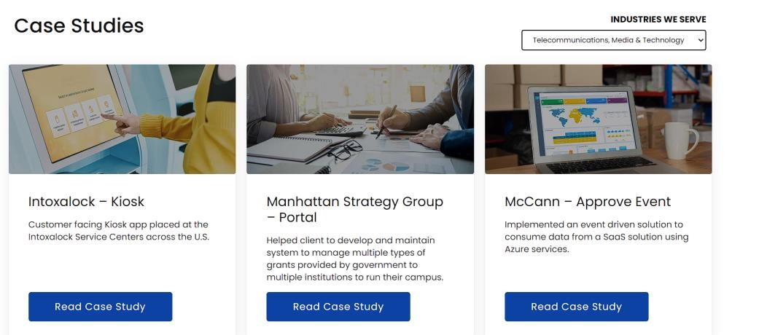

Fig 1.3.1 Case Studies for 1Rivet

### 1.5 SERVICES OFFERED BY THE COMPANY

* 1Rivet India offers a vast number of services in every domain in IT consultation as well as the emerging domain of RPA which is currently on the rise which deals with automation of workflow which is responsible for increasing the efficiency in the process flow and productivity enhancement.
* 1Rivet India offers three core domains in the service sector which is as per below:

1. **Automation**
2. **Technology**
3. **Transformation**

**A. Automation:**

* Automation365
* Discovery & Intake
* Self-Learning Automation
* Managed COE
* Assessment POC
* Test Automation

**B. Technology:**

* Digital Experience
* Data visualization analytics
* Software Engineering
* DevOps
* Cloud Architecture
* Quality Engineering
* Data Architecture and Engineering
* Artificial Intelligence

**C. Transformation:**

* Cloud Transformation
* Digital Transformation
* Technology Re-architecture
* Data Strategy
* Application Modernization
* Mergers & Acquisition

* We can understand about the utility and service provision by considering all the domains which are listed as per above.

**1.6 WHAT WE DO**

* We don't ever just hand you resumes; our Consulting experts pre-qualify your candidates, so you only see the best of the best. People are your greatest asset, and we are here to help close the gap.

**1.7 STRATEGIC RECRUITING**

* We have an incredible ability to find the most talented individuals available in the market: people with the right skills who will perfectly fit your culture and make an impact on day one.

**1.8 CONTRACTUAL HIRES**

* Many clients today want the ability to "try before they buy." This approach lowers the risk to your organization and ensures the person is the right fit for you.

**1.9 SCALABLE WORKFORCE**

* We give our clients access to scalable work force solutions with the ability to flex up and down, without the risk.

**1.10 EXPERIENCE OF THE COMPANY**

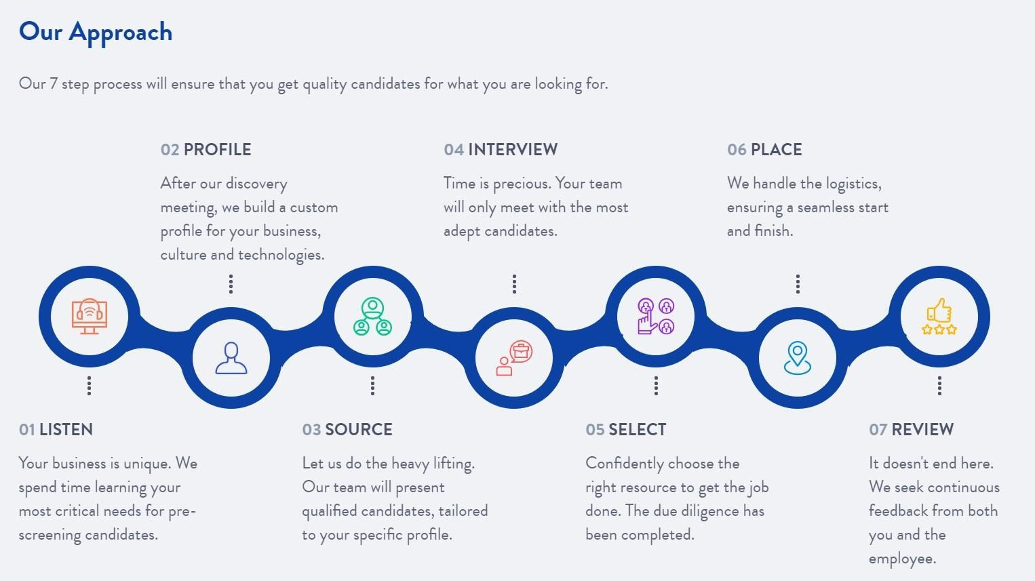

[Figure] process flow of Service at 1Rivet

1Rivet was found by Eric Middleton in the year of 2008. 1Rivet has its own head quarters in Washington D.C, New York, Toronto, Valsad and Surat. It has served 15+ years in the business with excellence. It has 225+ employees within the organization all over the globe.1Rivet has been featured in many noteworthy publishing media like

* Inc.5000’s list of fastest growing companies
* Virginia member’s top 50 IT consulting firms
* Consulting magazine’s fastest growing firms

We can surely determine and understand about the quality of work and service provided in the various domains constantly from last 15+ years which proves excellence of service and support among the client.

## CHAPTER-2 OVERVIEW OF DEPARTMENT IN ORGANIZATION

**2.1 DEPARTMENT AND WORK CARRIED OUT:**

**2.1.1 Mobile Application:**

* We are developing Android mobile applications using native code.
* We building powerful feature-rich mobile apps. We create mobile solutions for Android, and other platforms. Our focus on workforce automation help sour client’s business.

**2.1.2 Robotic Process Automation:**

* Robotic process automation (RPA) rapidly and flawlessly executes a range of tedious but essential digital tasks.
* Why choose 1Rivet for intelligent automation:
* Boost profitability by streamlining tedious workflows using sophisticated automation software.
* Reduce human error, inefficiencies, and overhead costs while expediting decision-making with one of the top RPA solutions companies.
* Leverage cost-effective [RPA benefits](https://www.1rivet.com/insights/benefits-of-rpa) with an ISO-certified, licensed UiPath partner.
* Seize opportunity with digital transformation powered by your own RPA service provider consultant and team.
* Amplify your earning potential with chatbot services that get your customers the answers they need—fast.
* Automate workflow and level up your earning potential with North America’s leading RPA company.

**2.1.3 Web Development:**

* A website is the identity of your Brand. We can help to create the online Presence of your Bussiness.Our websites are mobile & table friendly.It looks great on every device.
* We are developing Websites using Angular and .NET based on client requirements

**2.1.4 24/7 Live Support**

.

* We are available 24/7 to support client

**2.2 TECHNICAL SPECIFICATION OF DEPARTMENT:**

* Html
* Css
* Angular Js
* .Net

**2.3 EACH STAGE OF PRODUCTION:**

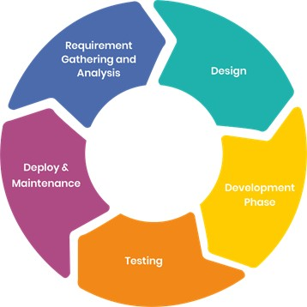

[Figure 2.3] Stage of Production

**Requirement Gathering Phase:**

* The fundamental step in the Life Cycle of any Software Development is Requirement Gathering Phase. It starts with gathering the requirements from our clients. In our organizations, this role is taken care of by the Managers and Team.

They interact with the clients, set up daily meetings, document the requirements and hand over the final documented requirement to the development team.

**Analysis Phase:**

* Once the Requirement Gathering phase is completed, the next task is to analyses the requirements and gets them approved by the clients. This is although Software Requirement Specification (SRS), which consists of all the requirements gathered and developed during the Requirements Gathering phase. This phase is mainly done by Project Managers and development team.

**Design Phase:**

* Once the Analysis Phase is over, next comes the most accurate, robust, efficient and cost- effective architecture of the product that needs to be developed. Usually, more than one design is proposed in this phase, and the best one is selected based on different parameter such as robustness, durability, timeline and cost-effectiveness.

**Development Phase:**

* This phase is where the actual implementation. In this phase, all develop rare involved. Developers are expected to follow certain predefined coding standards and guidelines they are expected to complete the project modules within the defined deadline for the project. This phase is also the longest and one of the most critical phases.

**Testing Phase:**

* Once the Development phase is completed, the next step is to test the developed software
* The developed software is sent to the testing team, where they conduct different types of testing thoroughly on the software and look for defects.

**Maintenance:**

* Once when the client starts using the developed systems, then the real issues come up and requirements to be solved from time to time.
* This procedure where the care is taken for the developed product is known as maintenance.

**CHAPTER-3 INTRODUCTION OF INTERNSHIP**

**3.1 INTERNSHIP SUMMARY:**

* An internship is best way to start experience of cooperative life. You apply your skills and knowledge what you studied in your college life to the industry environment.
* 1Rivet India given me this amazing opportunity.
* The Internship for about12 weeks and it involved a lot of learning activities all around.
* During my internship with the organization, I learned so many technical skills and professional skills.

**3.2 PURPOSE:**

* The Purpose of doing this internship was to get the experience of the cooperative before going to any company and expose students to real work of environment experience and at the same time, to gain the knowledge through hands on observation.
* Gain Valuable work Experience and Improving productivity and time management for full time employees, as interns often complete smaller tasks.
* Gain Confidence.

**3.3 OBJECTIVE:**

* One of the main objectives of an internship is to expose you to a particular job and a profession or industry.
* An internship provides a variety of benefits for college student who want to broaden their chances for landing a job and jump-starting their careers.
* Internships give you a taste of what a profession is like, help you build your resume and let you meet people who can help you in your career.
* The Main Aim of the internship provides a direction to the activities, helps to focus one result, and to assess the result achieved.

**3.4 SCOPE:**

* The scope of work and learning during the internship is a never ended path. Continuously I learnt new thing about the 1Rivet India then how our software provide various features to accomplish the task and how everything is so well connected.
* My learning path was start from Html, CSS, JS, BS and end with project using Angular Framework.

**3.5 TECHNOLOGY REVIEW:**

* + 1. **FRONTEND:**

|  |  |  |  |  |
| --- | --- | --- | --- | --- |
| **HTML** | • | HTML stands for Hyper Text  Markup  Language.HTML is the standard markup language for creating Web pages. | |  |
|  | • | HTML describes the structure of a Web page. | |  |
|  | • | HTML consists of a series of elements.HTML elements tell the browser how to display the content**.** | |  |
| **CSS** |  | * Cascading Style Sheets (CSS) is a stylesheet language used to describe the presentation of a document written in HTML or XML (including XML dialects such as SVG, MathML or XHTML). * CSS describes how elements should be rendered on screen, on paper, in speech, or on other media. | |  |
| **JAVASCRIPT** | • | | JavaScript is used to develop interactive web applications. JavaScript can power features like interactive images, carousels, and forms. |  |
|  | • | | The language can be used with back-end frameworks like Node. js to power the mechanics behind a web page. |  |
| **ANGULAR** | • | | Angular is an application design framework and development platform for creating efficient and sophisticated single-page apps. |  |
|  | • | | A collection of well integrated libraries that cover a wide variety of features,including routing,  forms management, client-server communication, and more. |  |
| **BOOTSTRAP** | • | | Bootstrap is a free front-end framework for faster and easier web development |  |
|  | • | | Bootstrap includes HTML and CSS based design templates for typography, forms, buttons, tables, navigation, modals, image carousels and many other.  plugins |  |

[Table 3.5.1] Front End

* + 1. **BACKEND:**

|  |  |  |
| --- | --- | --- |
| **.NET WEB API** | * The term API stands for Application   Programming Interface. ASP.NET  Web API is a framework for building Web APIs, i.e. HTTP based services on top of .NET Framework.   * The most common case of using Web   API is building RESTful services. |  |
| **MICROSOFT**  **SQL SERVER** | * It is a software, developed by Microsoft, which is implemented from the specification of RDBMS. * It is also an ORDBMS. * It supports SQL (SEQUEL) language which is an IBM   Product, nonprocedural, common database and case  In sensitive language. |  |

[Table 3.5.2] Back End

**3.6 INTERNSHIP PLANNING:**

* Before during internship in an organization it’s very important to first know about the company.
* Before starting an internship review the different technology company work, which methodology follows etc.

**3.7 INTERNSHIP LEARNING:**

**3.7.1 FRONTEND:**

* + - * In the Learning Phase of my Internship, start with ⚫ Basics of Html5 and its Structural Elements.
      * Basics of CSS
      * CSS Flexbox
      * Basics of Css3
      * 2D /3D Transform
      * Responsiveness
      * JavaScript Fundamentals
      * Asynchronous JavaScript
      * Es6+ Features
      * Event & Dom Manipulation
      * Angular Framework
      * Components
      * Binding
      * Project Folder Structure As per Standards
      * Modules and Routing ⚫ Forms

### 3.8 UI ASSESSMENT

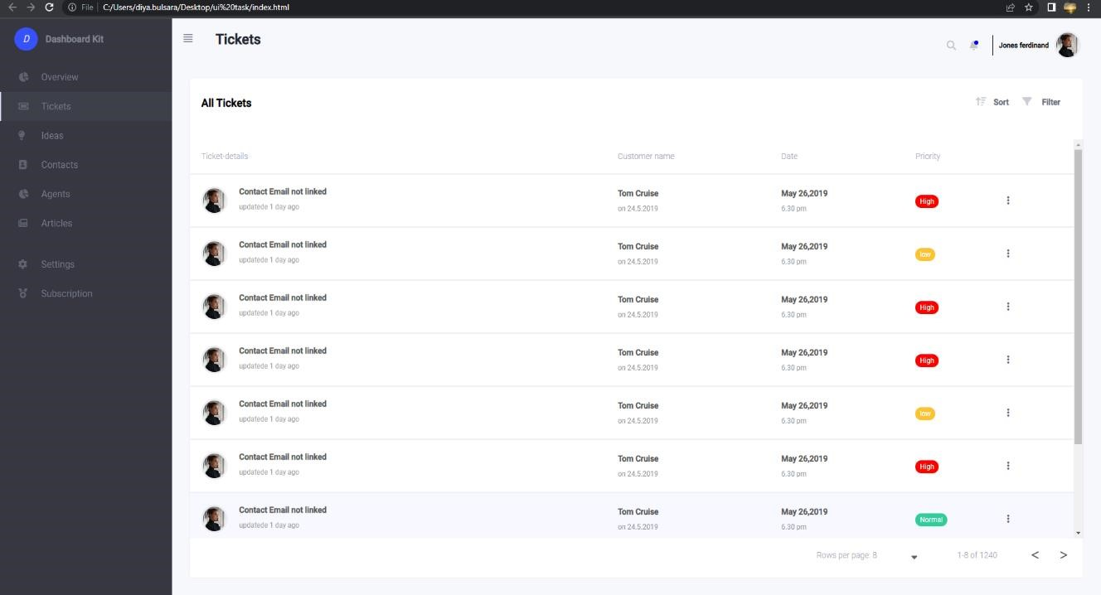

[Figure 3.8] create dashboard

### 3.9 JAVASCRIPT ASSESSMENT

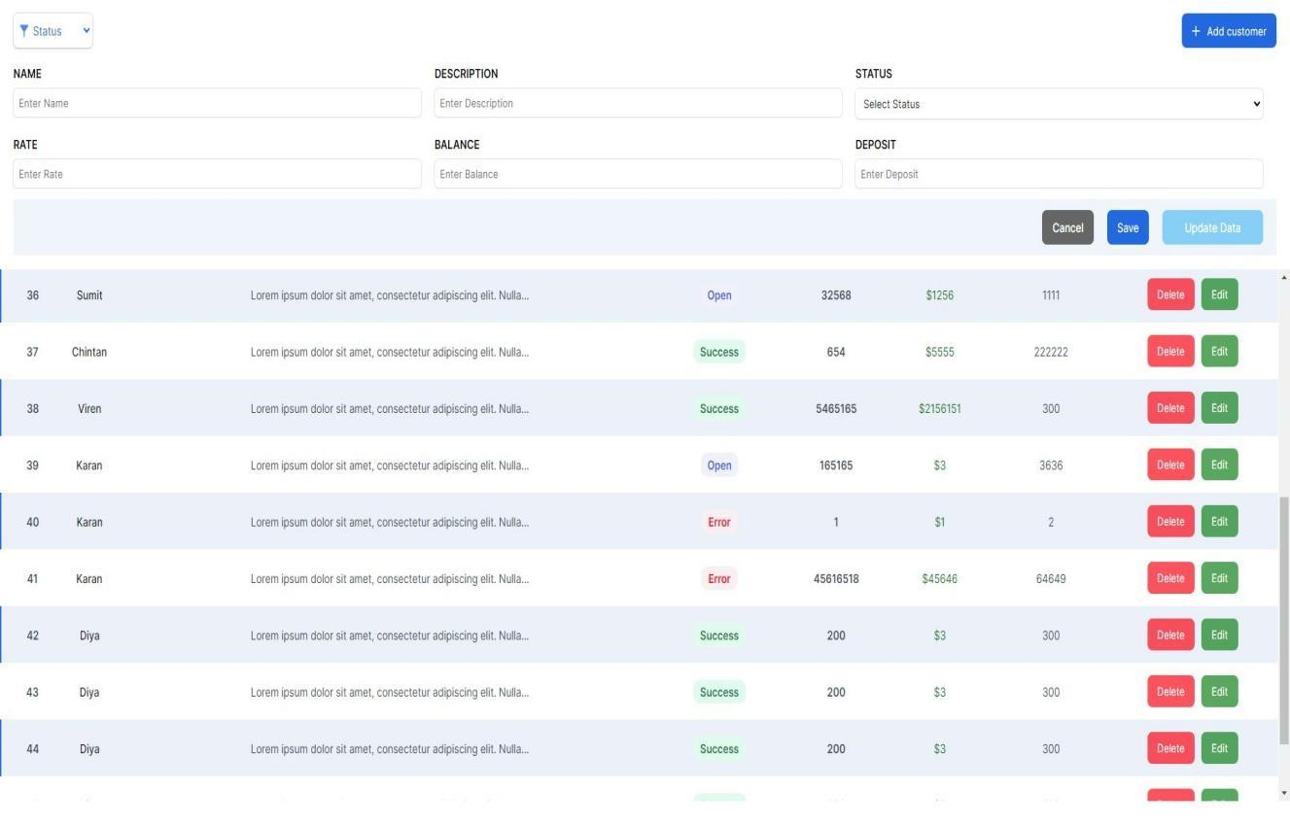

[Figure 3.9] create form & Table

### 3.10 ANGULAR ASSESSMENT

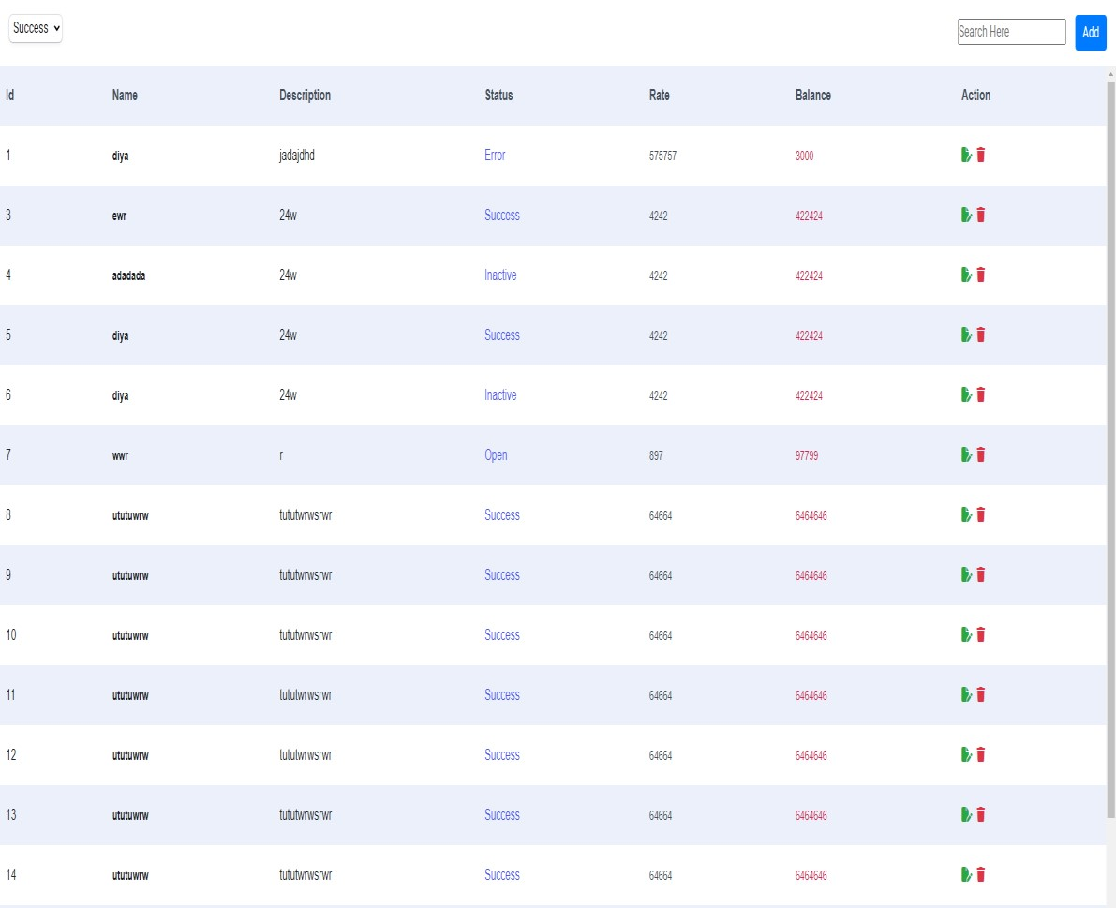

[Figure 3.10] create table

## CHAPTER-4 SYSTEM ANALYSIS

**4.1 EXISTING SYSTEM:**

* Existing system is all about that we have to make request to a person to book their seat or request to the different person.
* This system takes too much time and make conflicts such reasons are human mistakes, writing error, record mistake etc no technical errors.

**4.2 PROPOSED SYSTEM:**

* The application should allow employees to book a desk in advance or on the day of their visit, choose their preferred location and amenities, and view availability in real-time.
* The application should also integrate with the organization's existing systems, such as calendars and employee databases, to streamline the booking process.
* Furthermore, the application should allow organizations to track desk usage and occupancy rates to optimize office space and ensure compliance with social distancing guidelines.

**4.3 TOOLS & TECHNOLOGIES USED FOR PROJECT IMPLEMENTATION:**

**4.3.1 TOOLS:**

* Visual Studio Code
* Xampp server for database connection
* MS SQL Server
* Jenkins

**4.3.2 TECHNOLOGY:**

* Front End: HTML, CSS, JS, Angular
* Back-End: MS SQL Server, .NET , Web API
* DEVOPS: Xampp Server, Jenkins
* QA: Java, Selenium, Jira

System Analysis

**4.4 FEATURE OF SYSTEM:**

* Login/Register
* User Friendly Design
* View Menu
* Seat Booking
* Booking History
* Approval/Denied
* Profile View
* Admin Dashborad

## CHAPTER-5 SYSTEM DESIGN AND METHODOLOGY

**5.1 SYSTEM DESIGN & METHODOLOGY:**

**5.1.1 Project Development Approach:**

* **Agile Process Model**: This is an iterative and collaborative approach that involves working closely with the client to develop and deliver the software in small, incremental stages. It emphasizes frequent communication, continuous feedback, and adaptability to change, which can be particularly useful in complex and rapidly changing projects.
* **Advantages of Agile Process Model:** Generates working software quickly and early during the software life cycle. It is easier to test and debug during a smaller iteration. Clients can respond to each build. Lowers initial delivery cost.

**5.1.2 Modules**

* **Register**: The system shall allow the user to click on the " Register " button only when all the required fields are filled with valid input. Once the user clicks the " Register " button, the system shall process and redirect to the Sign In page.
* **Log In:** The user can log in to the Deskbook Application so that the user can have access to the application.
* **Book Seat:** Users can book the seat as per availability.
* **Request History:** The user can view all the requests made by the employee. User can “Accept” or “Reject” the request made by the employee.
* **Booking History:** User will be able to view seat bookings and cancel their seat booking on clicking the “Booking History”.

* **User Profile:** This user Profile will be on the home page and will redirect the user to the Profile page. The profile page will display the user information.

This will provide the functionality to manage the profile details.

* **Seat Configuration:** The user should be able to add new seats or remove the seats as per the requirement.
* **Notification:** The user should receive Notification for Requested Seat, Booked Seat and Cancelled seat. The user should Receive a Notification for Request sent for seat to Hybrid user for Accept the seat or Reject the Seat.
* **Dashboard:** This section is only visible to the admin, admin can login to see various data regarding the activities done in the system.

**5.1.3 Timeline** **Chart**

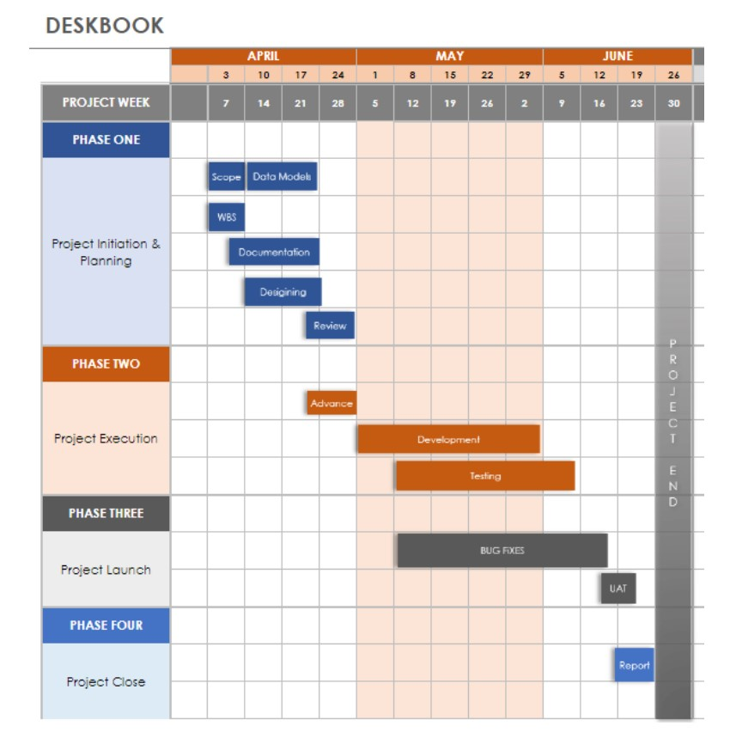

### [Fig 5.1] Timeline Chart

**5.1.4 Use Case Diagram for Employee and Admin**

• Define: A use case diagram is a type of diagram in software engineering that depicts the interactions between a system or software application and its users or other systems. It is used to illustrate the functionality and behaviors of a system from a user's perspective.

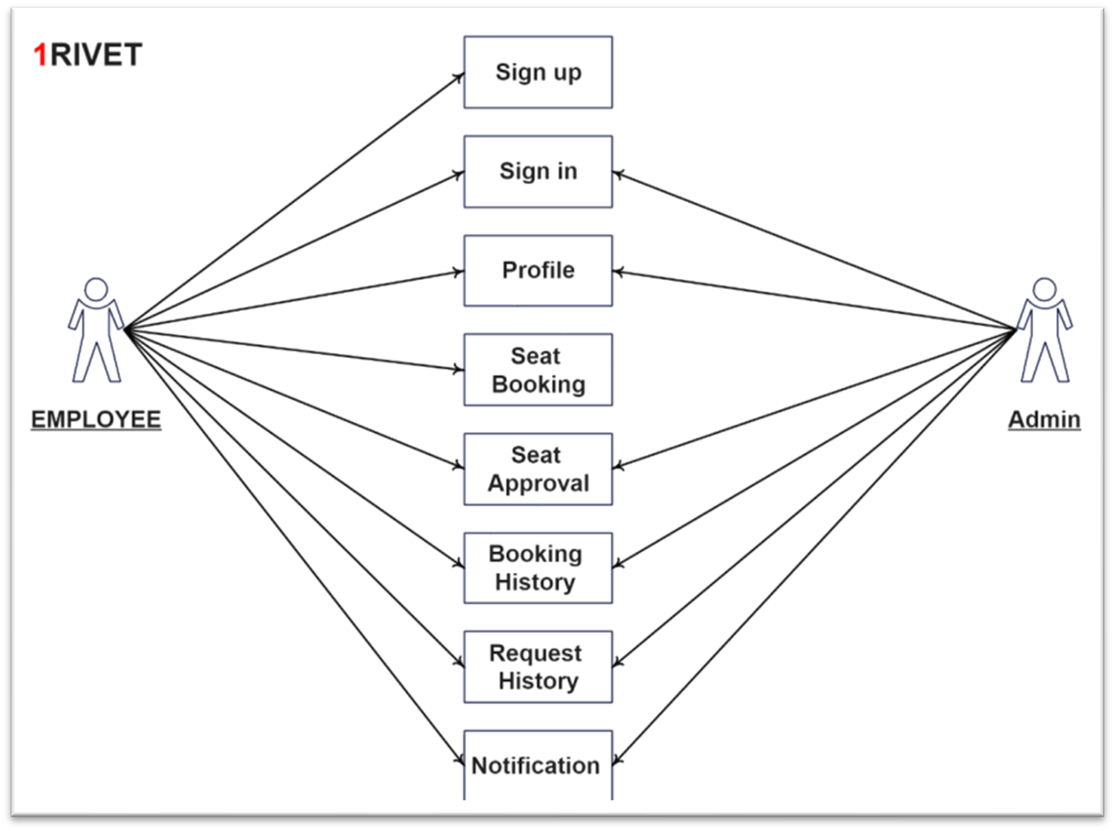

[Figure 5.1.1] Use Case Diagram

**5.2 Sequence Diagram:**

* Define: A sequence diagram is a type of interaction diagram in UML (Unified Modeling Language) that illustrates the flow of messages and interactions between objects or components in a system or software application. It shows the order in which messages are exchanged between different components and how they are processed to achieve a specific goal.

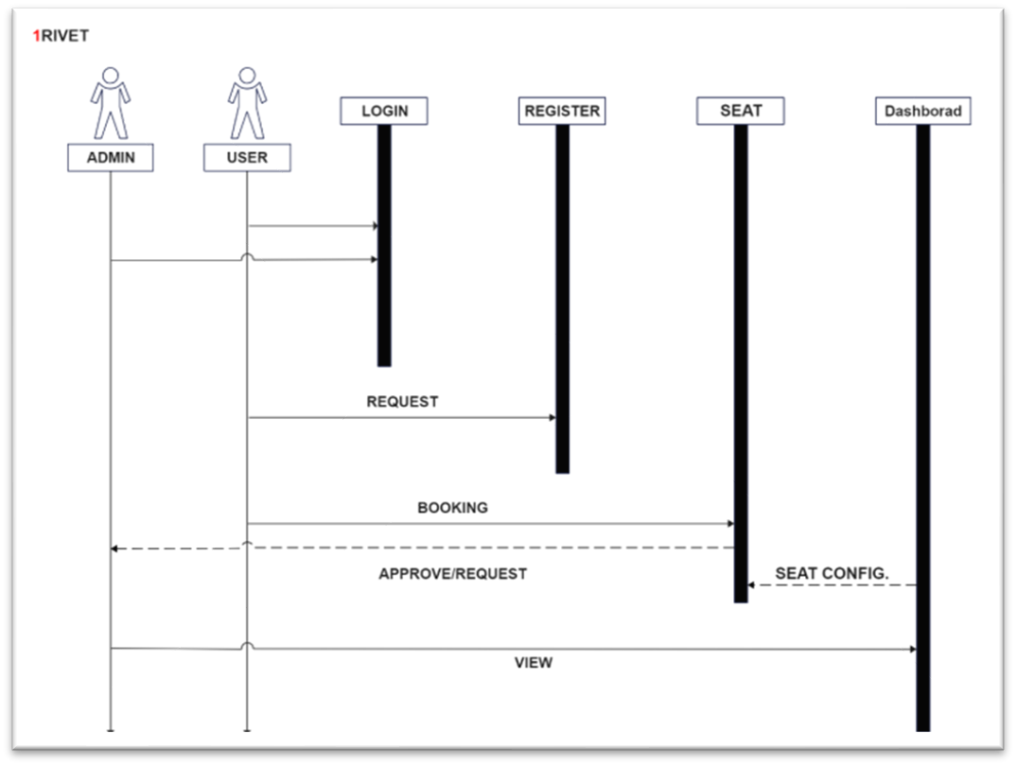

[Figure 5.2] Sequence Diagram

**5.3 Activity Diagram:**

* Define: An activity diagram is a type of UML (Unified Modeling Language) diagram that is used to model workflows or processes in a system or software application.

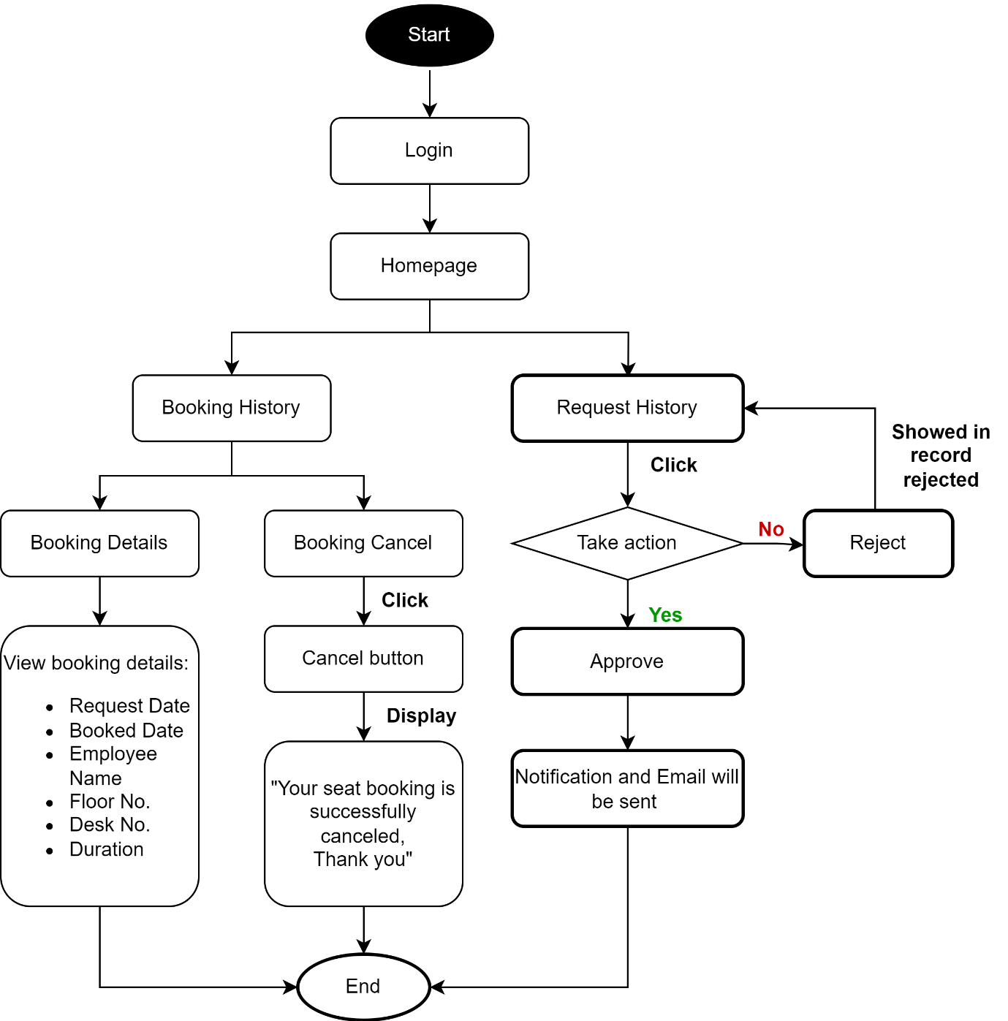

[Figure 5.3 ] Activity Diagram

**5.4. DATA MODEL**

Data model is a conceptual representation of data objects, relationships between them, and the rules that govern those relationships.

As the member of the data engineering team which is a part of the back-end forces, my roles and responsibility consists of below matter of facts:

* Creation of Data Models as per the Software Requirement Specification, Business Requirement Document and User stories
* Collaboration with .NET backend team for development of database using EF Core and review of modules as per sprint

As per my role and current status of the live project development, I have contributed into developing the data model which was approved by authorities and was taken as the reference for the database creation and development by the DOTNET team.

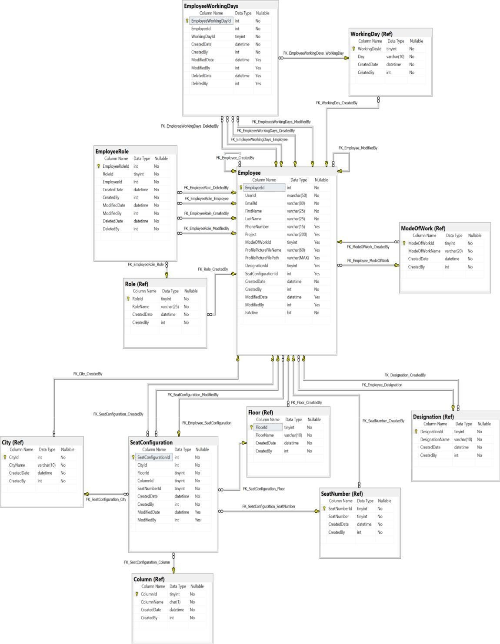

[Figure 5.4] Sprint 1 Data model

**5.5 System Design**

### 5.5.1 DATA MODELLING CONCEPTS

* Data modeling is the process of creating a visual representation of data and its relationships in a database. It helps to ensure that data is organized, consistent, and accurate, and that it meets the needs of users and applications.
* I have worked on a Banking management system as the part of the modelling concepts demo.
* Which I am going to demonstrate here in this report.
* There are three main types of data models: conceptual, logical, and physical.

**5.5.2 CONCEPTUAL DATA MODEL**

* The conceptual data model is an abstract representation of data that focuses on the high-level concepts and relationships between them.
* It does not contain any technical details. This model is usually created in the early stages of the project, where the main focus is on understanding the business requirements, identifying entities, and defining relationships between them.
* The conceptual data model is typically created using entity-relationship (ER) diagrams or similar techniques.
* ER diagrams use entities to represent real-world objects or concepts, such as customers, orders, or products, and relationships to represent how these entities are related, such as one-to-many or many-to-many relationsh

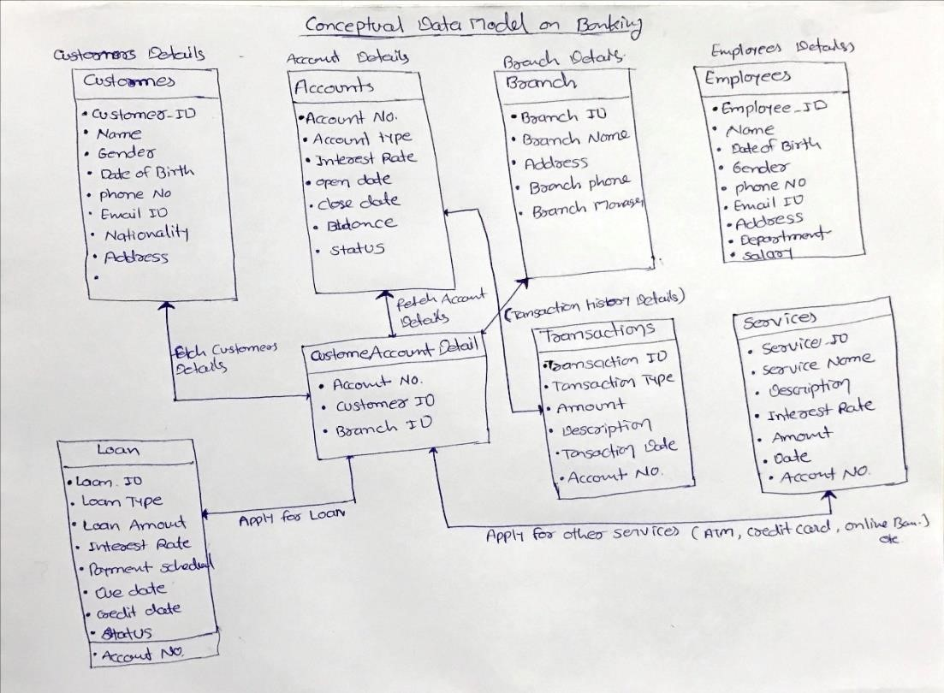

[Figure 5.2.2] Conceptual Data Model of Banking System

**5.2.3. LOGICAL DATA MODEL**

The logical data model is a more detailed representation of data that focuses on the business requirements and rules for data storage, processing, and retrieval.

It includes entities, attributes, relationships, and constraints. It is independent of the specific database management system (DBMS) and can be implemented on any platform.

The logical data model is usually created after the conceptual data model, as it requires a more detailed understanding of the business requirements and rules.

It includes more specific details about the data, such as data types, lengths, and precision. This model is created using data modeling techniques such as entity-relationship diagrams or Unified Modeling Language (UML) diagrams.

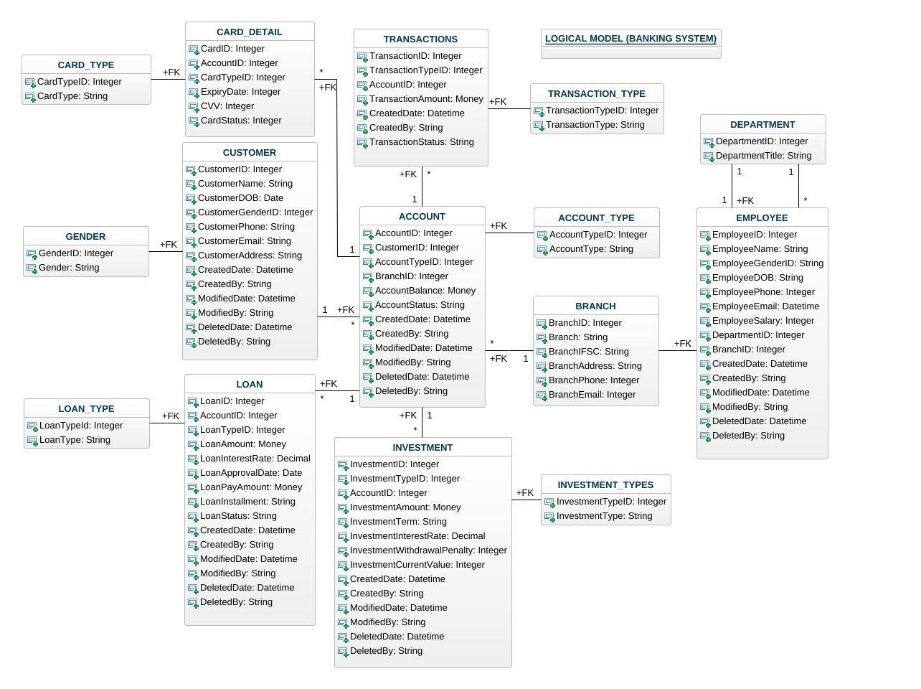

#### [Figure 5.2.3] Logical Data Model for Banking System

**5.2.4. DATA DICTIONARY:**

The data dictionary provides a central repository of metadata that is used by database administrators, developers, and users to understand the structure and content of the database.

It ensures consistency and accuracy of the data by enforcing rules and constraints and can be used to generate documentation, reports, and data dictionaries.

The data dictionary is also used to manage changes to the database structure and to ensure that data remains valid and accurate over time.

* **Data Elements**: data dictionary defines the data elements used in the database, including the name, description, data type, size, and other attributes of each field. It also specifies the rules for entering and validating data, such as minimum and maximum values, data formats, and default values.

* **Relationships:** data dictionary documents the relationships between the data structures in the database. It specifies the type of relationship (one-to-one, one-to-many, manyto-many), the fields involved, and the constraints on the relationship, such as referential integrity and cascading updates or deletes.

* **Constraints:** A data dictionary defines the constraints on the data, such as primary keys, foreign keys, unique constraints, and check constraints.

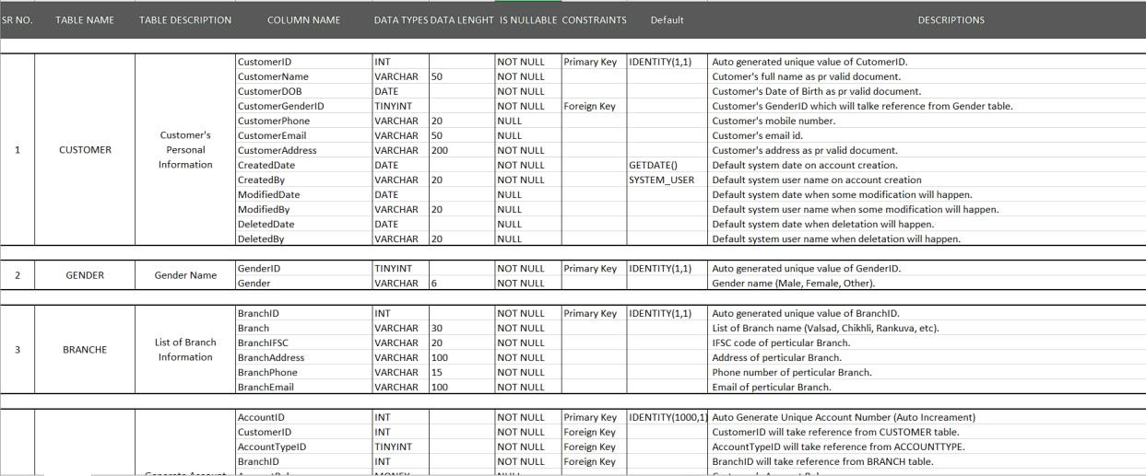

#### [Figure 5.2.4] Data Dictionary demo for Banking System

**5.2.5. PHYSICAL DATA MODEL**

A physical data model (PDM) is a detailed view of the data that is specific to a particular database management system (DBMS).

It defines the actual structure of the database, including tables, columns, indexes, and keys, and specifies the data types, constraints, and rules that are required to implement the database.

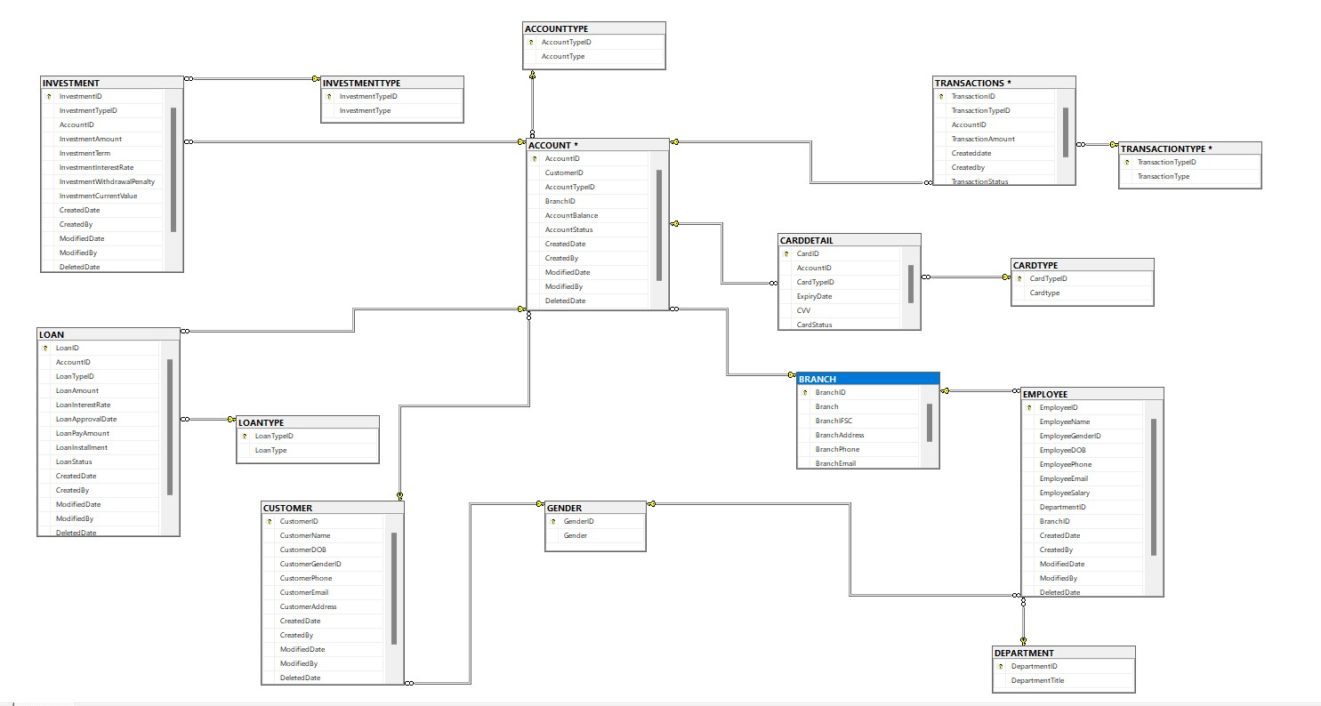

[Figure 5.2.5.] Physical Data Model for Banking Syste

**CHAPTER-6 IMPLEMENTATION**

**6.1 Snapshots:**

**6.1.1 Register:**

• Allows user to register in the application and once the user is registered the system shall process and redirect to the Sign In page.

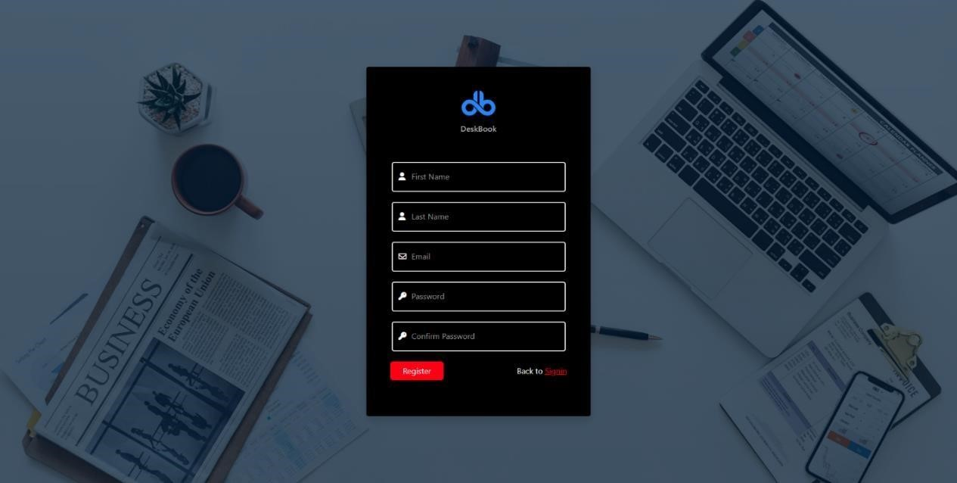

### [Figure 6.1.1] Register Page

**6.1.2 Sign in:**

• Allows the user to login in the Deskbook Application so that the user can have access to the application.

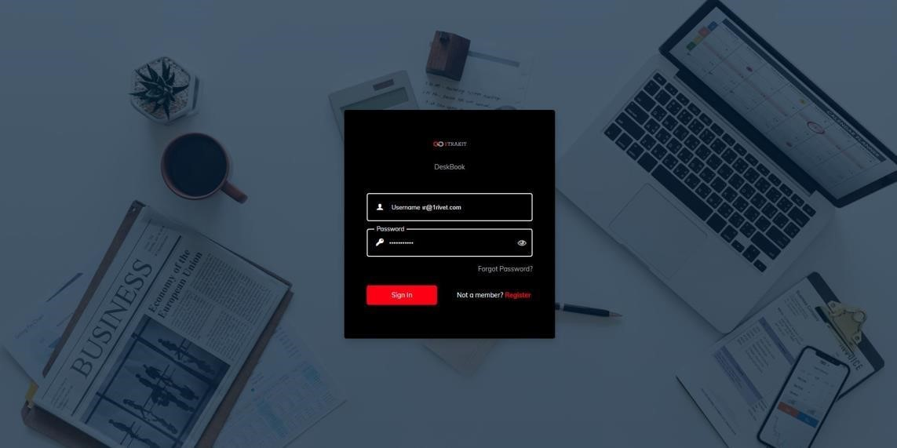

### [Figure 6.1.2] Sign in

**6.1.3 Forgot Password**

• If user forgets the password then he/she can click on forgot-password and be redirected to reset password.

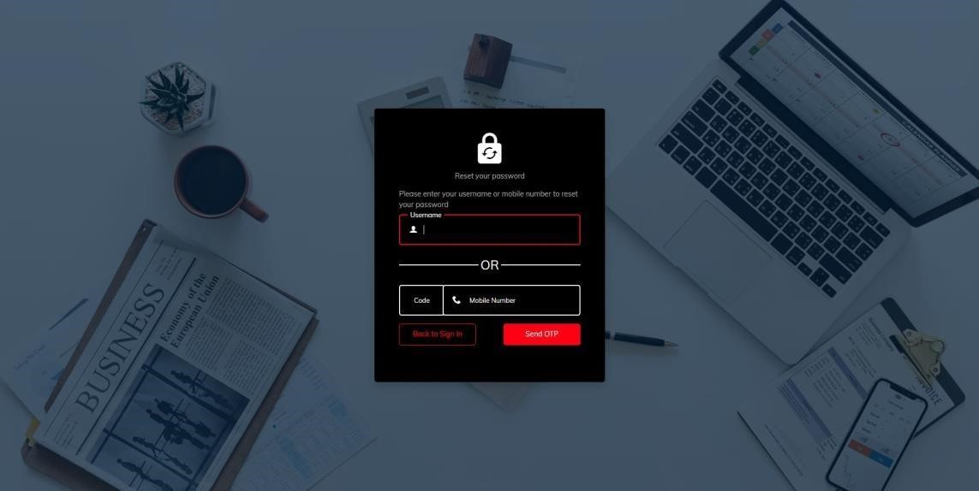

### [Figure 6.1.3] Forgot password

**6.1.4 Reset Password:**

* Allows the user to reset the password. And user can easily log in to the website .

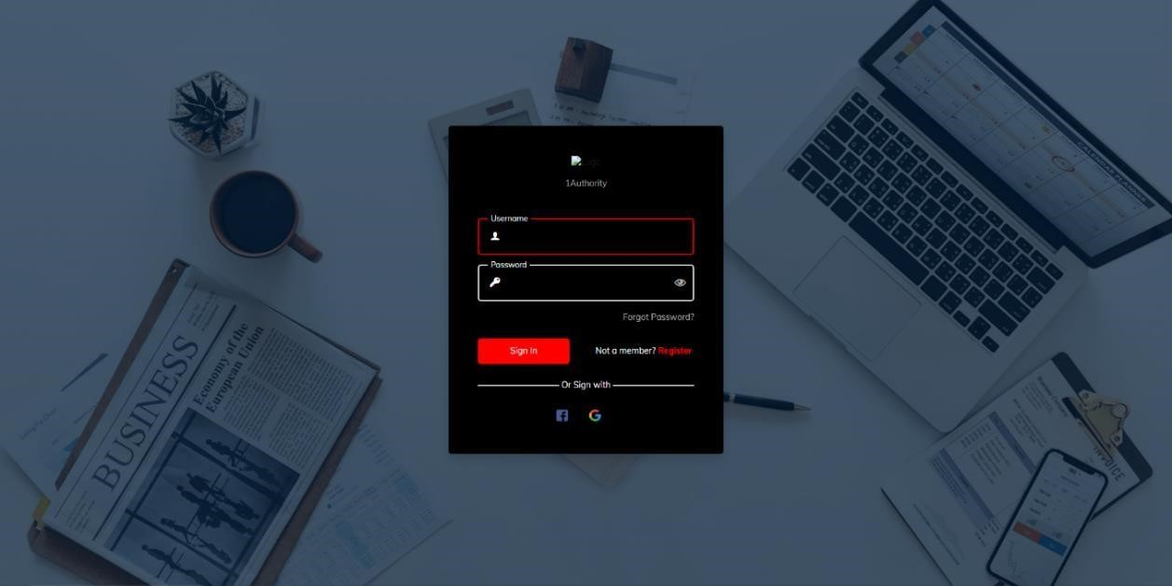

**[Figure 6.1.4] Reset Password**

**6.1.5 Landing Page:**

• Allows the user to book the seat, see booking history and request history in addition provides the option to logout.

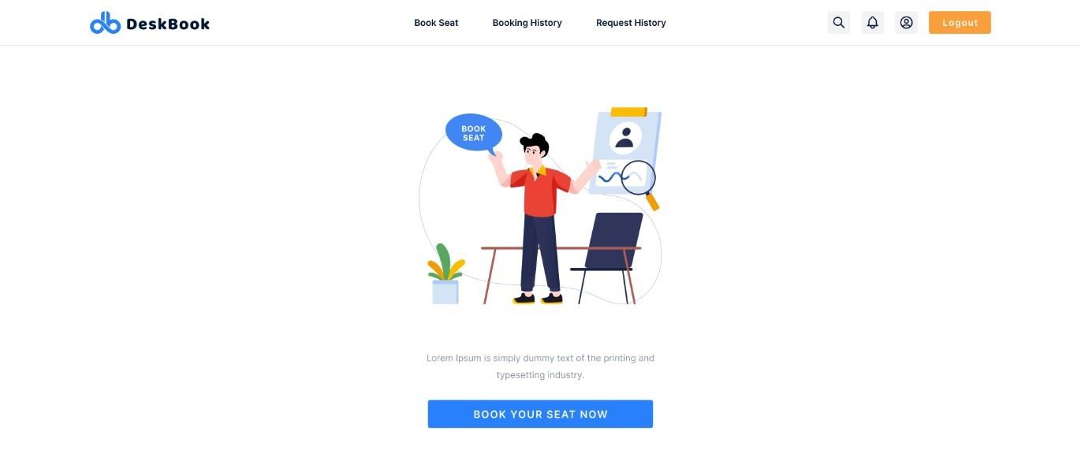

[Figure 6.1.4] Landing Page

**6.1.6 Book Seat:**

• Allows the user to see temporarily unavailable seats which cannot be booked.

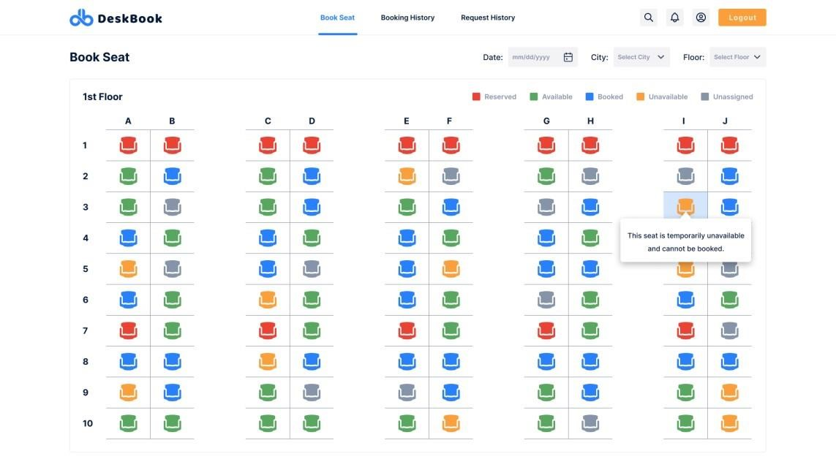

### [Figure 6.1.5] Book Seat

**6.1.7 Request History:**

* The user to see the request history of seats.

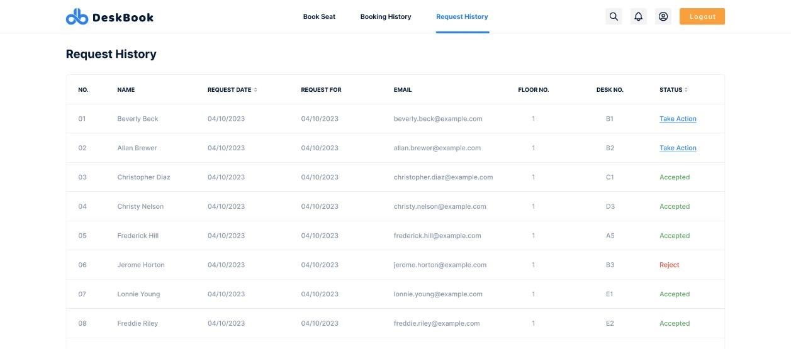

### [Figure 6.1.7] Request History

**6.1.8 Profile Page:**

* The profile page will display the user information. This will provide the functionality to manage the profile details.

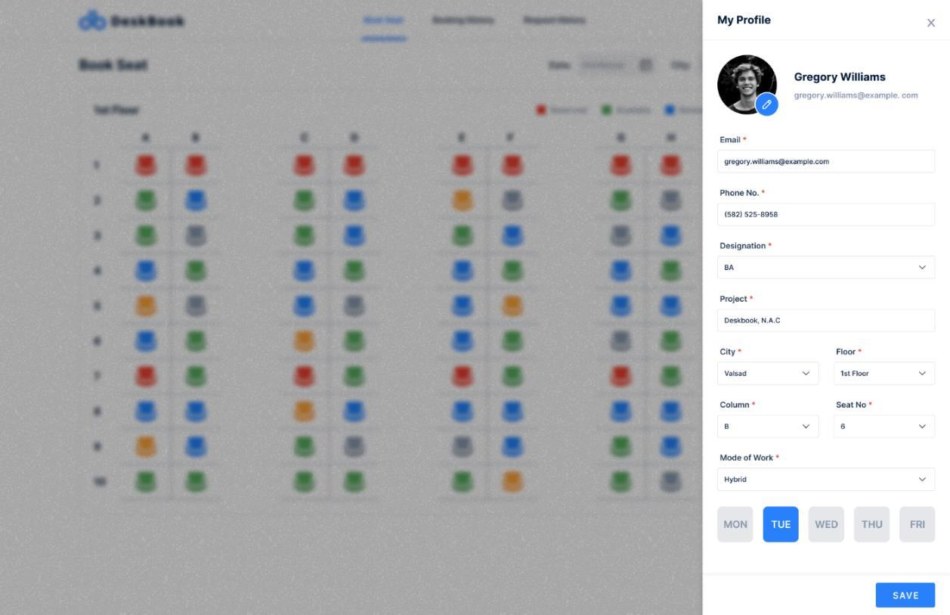

[Figure 6.1.8] Profile Page

**6.1.9 Notification:**

* The user should receive Notification for Requested Seat, Booked Seat and Cancelled seat. The user should Receive Notification for Request sent for seat to Hybrid user for Accept the seat or Reject the Seat.

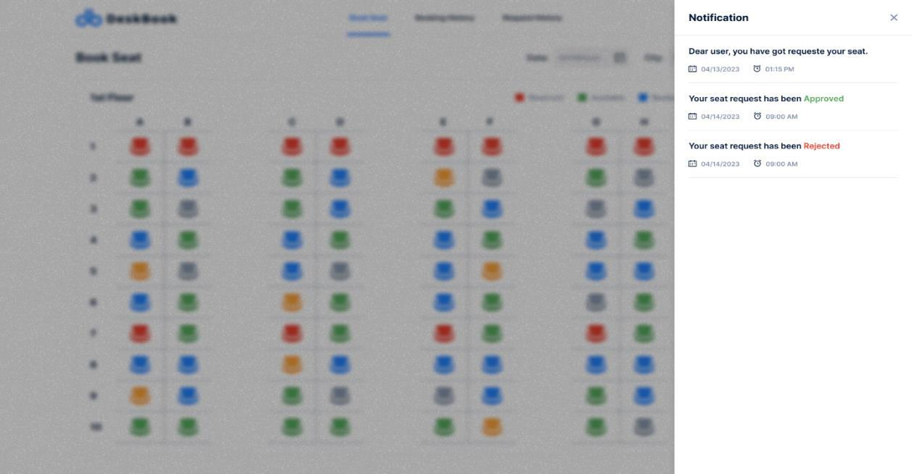

### [Figure 6.1.9] Notification Page

**6.1.10 Reserved Seat:**

* Informs the user about the reserved seat and shows the detail of the person who has reserved it.

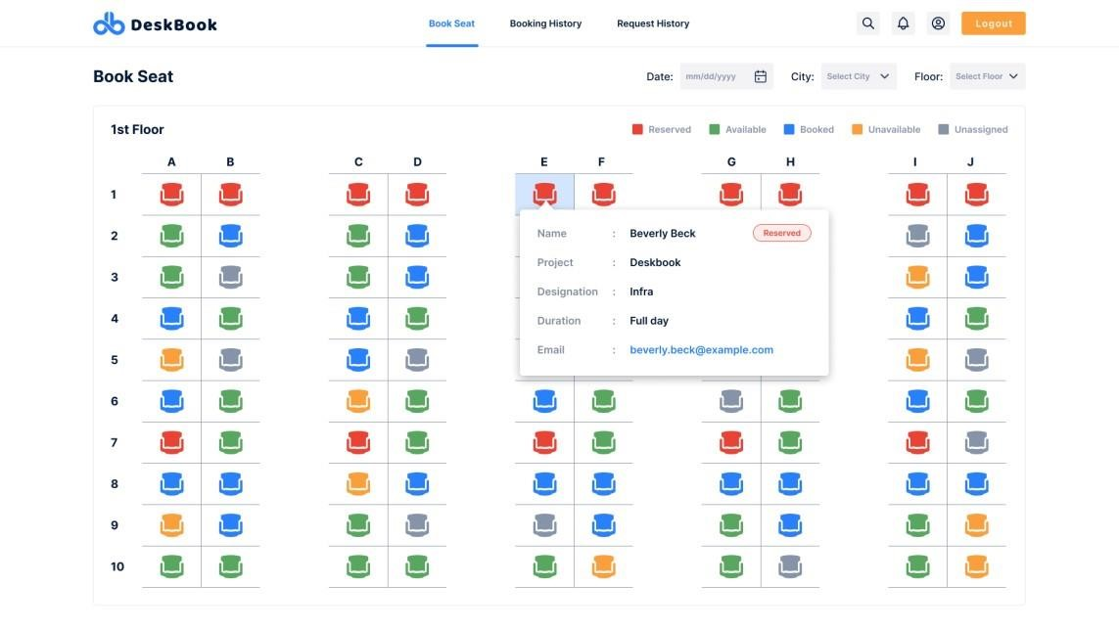

### [Figure 6.1.10] Reserved Seat

**6.1.11 Request Pop-up:**

* Informs the user about the response of the book-seat request being made .

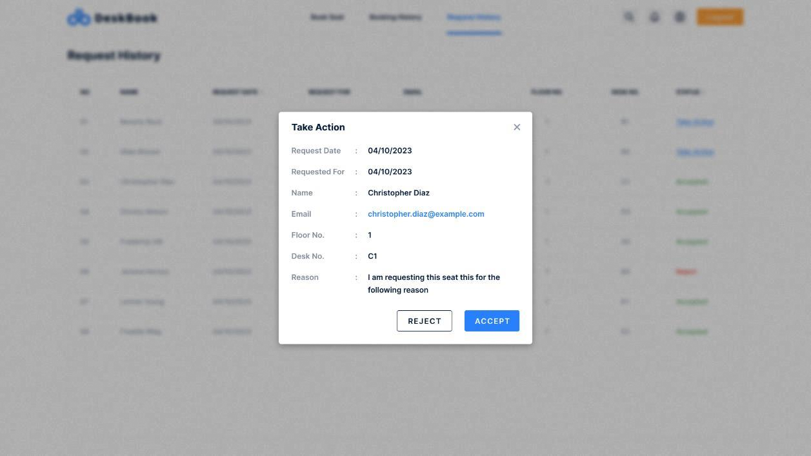

### [Figure 6.1.11] Request Pop-up

**6.1.12 Reason Pop-up:**

• Informs the user about the response of the book-seat request being made.

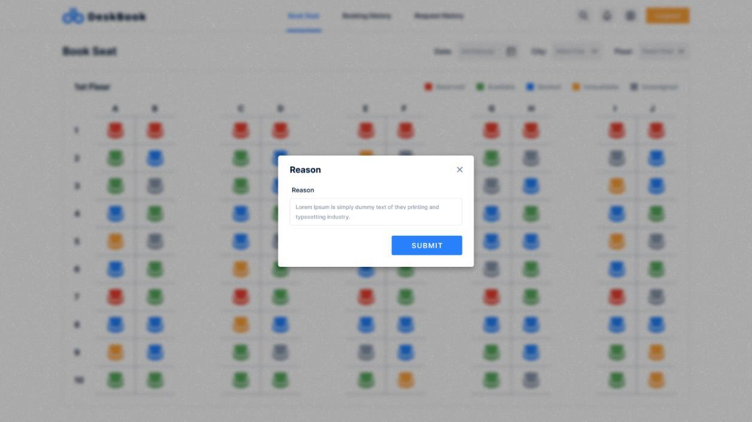

### [Figure 6.1.12] Reason Pop-up

**6.1.13 Search Employee:**

• User can easily search the name of the employee from book seat.

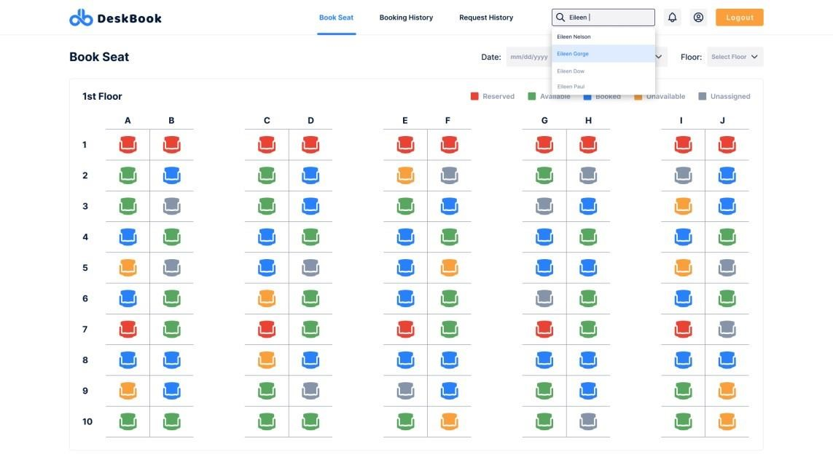

### [Figure 6.1.13] Search Employee

**6.1.14 Cancel Confirmation Pop-up:**

• When the user cancels the booking of the seat, then Pop-up appears for confirmation of cancellation.

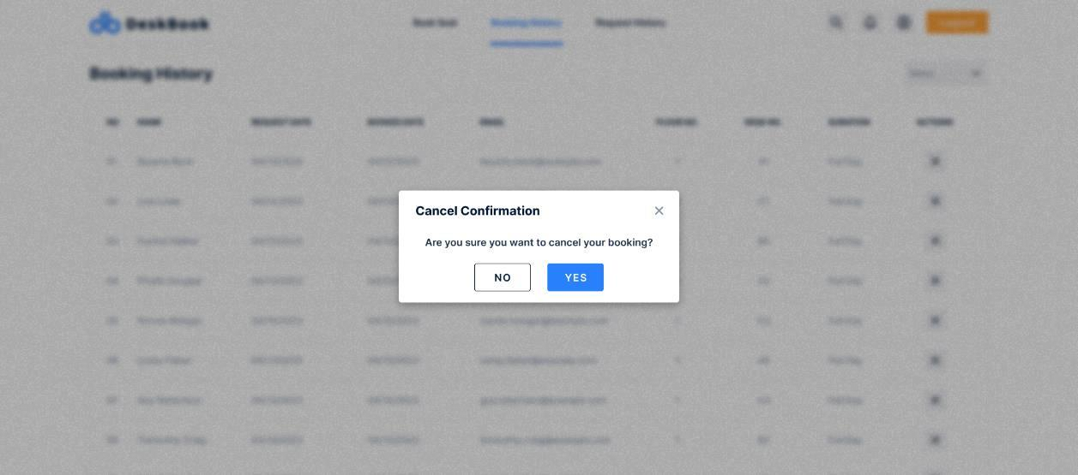

[Figure 6.1.14] Cancel Confirmation Pop-up

**TEST CASES:**

|  |  |  |  |  |  |
| --- | --- | --- | --- | --- | --- |
| **TestID** | **Case** | **Test Data** | **Expected Result** | **Actual Result** | **Pass/**  **Fail** |
| 1 | Sign In | Email Id ,  Password | User will redirected to the Home Page | User will redirected to the Home Page. | Pass |
| 2 | Forget Password | Email  ID,New Passsword,C onfirm  Password | If Email ID is valid and authorized then new password is set by recived mail | If Email ID is valid and authorized then new password is set by recived mail | Pass |
| 3 | Sign up | User  Name,Email  ID,Password | User will register with proper Details | User will register with proper  Details | Pass |
| 4 | Home  Page | Select  Notification,  Search  Employee,  Profile | User will see the profile detail,Search Employee Seat,see the notification | User will see the profile detail,Search Employee  Seat,see the notification | Pass |
| 5 | Book Seat | Select Seat  Booking,  Notification,  Search Employee,Pr  ofile | User will Book a Seat, see the profile detail,Search  Employee Seat,see the  notification | User will Book a Seat, see the profile detail,Search Employee  Seat,see the notification | Pass |
| 6 | Profile | Select  Profile | User will View or  Edit Profile Details | User will View or  Edit Profile  Details | Pass |
| 7 | Logout | Select  Logout | User will redirected to the Sign in Page | User will redirected to the  Sign in Page | Pass |

**CHAPTER 7 CONCLUSION AND DISCUSSION**

**7.1 OVERALL ANALYSIS OF INTERNSHIP:**

* In conclusion, a desk booking application is an essential tool for modern workplaces, especially in today's fast-paced and flexible work environments. It offers a streamlined way to manage workspace reservations, reduce conflicts, and optimize space utilization, resulting in increased productivity, improved communication, and cost savings.

* By implementing a desk booking application, organizations can provide their employees with a flexible and user-friendly way to book workspaces, thus enhancing their overall work experience. Moreover, desk booking applications can help organizations adapt to the changing needs of their workforce, allowing them to scale up or down as needed while still optimizing their workspace utilization.

* In Future work, Desk booking applications are becoming increasingly popular as more companies move towards flexible work arrangements and remote work. The future scope of desk booking applications is bright, and it is expected that the demand for such applications will only increase in the coming years. Integration with other workplace management software, Advanced features, Improved user experience.

* The future of desk booking applications looks bright as more companies recognize the benefits of flexible workspace arrangements and invest in tools to optimize their workplace management.

**7.2 SUMMARY OF INTERNSHIP:**

* This report is a reflection of the learning and experience acquired through an opportunity.

* During my internship a 1RIVET INDIA, I was introduced to some new technologies, frameworks, and languages.

* I get to know how real-time organizations work. What is their professional approach to deal with clients and Team.

**REFERANCES**

* The following websites were referred during the accomplishment of our project:

1. [https:www.javatpoint.com/web-api](http://www.javatpoint.com/web-api)
2. <https://www.tutorialsteacher.com/webapi>
3. <https://www.tutorialspoint.com/csharp/csharp_interfaces.html>
4. https://www.c-sharpcorner.com/article/create-simple-web-api-in-aspnet-mvc/
5. [Transact-SQL reference (Database Engine) - SQL Server | Microsoft](https://learn.microsoft.com/en-us/sql/t-sql/language-reference?view=sql-server-ver16)[Learn](https://learn.microsoft.com/en-us/sql/t-sql/language-reference?view=sql-server-ver16)
6. https://[lwww.w3schools.com/html/](http://www.w3schools.com/html/)
7. https://l[www.w3schools.com/css/](http://www.w3schools.com/css/)
8. https://l[www.w3schools.com/js/](http://www.w3schools.com/js/)
9. <https://lwww.w3schools.com/bootstrap/>
10. https://l[www.w3schools.com/php/](http://www.w3schools.com/php/)
11. [https://laravel.com](https://laravel.com/)